Machine learning

Bl.en.u4cse22077

Lab-1

Q1:

Consider the given list as [2, 7, 4, 1, 3, 6]. Write a program to count pairs of elements with

sum equal to 10.

CODE:

a= [2, 7, 4, 1, 3, 6]

def paircount(a):

count = 0

for i in range(len(a)):

for j in range(i + 1, len(a)):

if a[i] + a[j] == 10:

count += 1

return count

print(" pairs of sum 10", paircount(a))

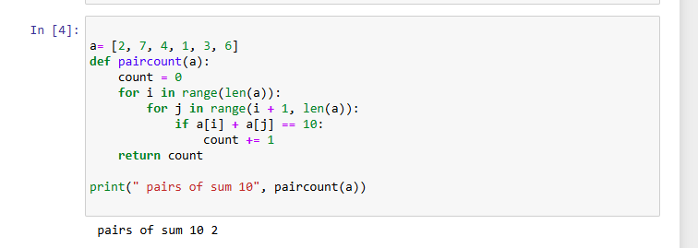

Q2

Write a program that takes a list of real numbers as input and returns the range (difference

between minimum and maximum) of the list. Check for list being less than 3 elements in

which case return an error message (Ex: “Range determination not possible”). Given a list

[5,3,8,1,0,4], the range is 8 (8-0).

CODE:

a = [5, 3, 8, 1, 0, 4]

def range(a):

if len(a) < 3:

return "0"

min = a[0]

max = a[0]

for num in a:

if num < min:

min = num

if num > max:

max = num

return max- min

print("range ", range(a))

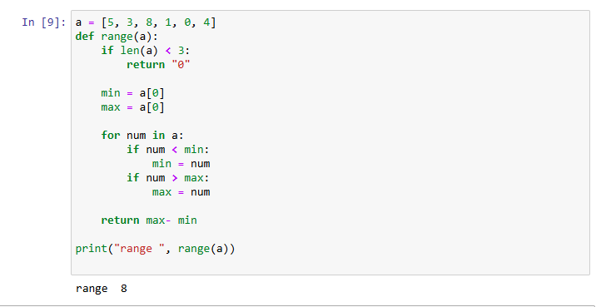

Q3

Write a program that accepts a square matrix A and a positive integer m as arguments and

returns A^m

CODE:

A = [

[2, 1],

[1, 3]

]

m = 2

def custom_range(n):

i = 0

Result = []

while i < n:

result.append(i)

i += 1

return result

def matrix_multiply(A, B):

n = len(A)

result = []

for i in custom_range(n):

row = []

for j in custom_range(n):

sum = 0

for k in custom_range(n):

sum += A[i][k] * B[k][j]

row.append(sum)

result.append(row)

return result

def matrix_power(A, m):

n = len(A)

result = []

for i in custom_range(n):

row = []

for j in custom_range(n):

if i == j:

row.append(1)

eLSE row.append(0)

result.append(row)

base = A

while m > 0:

if m % 2 == 1:

result = matrix_multiply(result, base)

base = matrix_multiply(base, base)

m = m // 2

return result

print("Matrix A^m:")

result = matrix_power(A, m)

for row in result:

print(row)

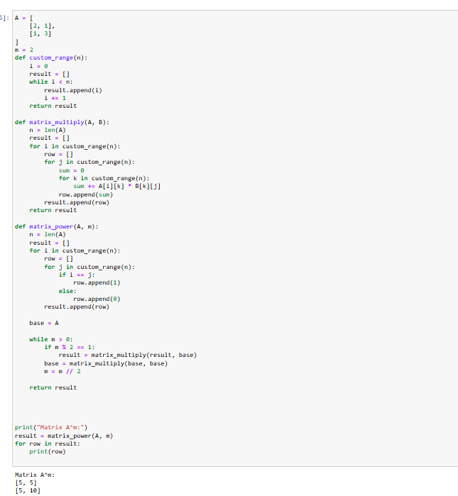

Q4

Write a program to count the highest occurring character & its occurrence count in an input string. Consider only alphabets. Ex: for “hippopotamus” as input string, the maximally occurring character is ‘p’ & occurrence count is 3

CODE:

s = "hippopotamus"

def count_highest_occurrence(s):

frequency = {}

max_char = ''

max_count = 0

for char in s:

if 'a' <= char <= 'z' or 'A' <= char <= 'Z':

if char not in frequency:

frequency[char] = 0

frequency[char] += 1

if frequency[char] > max_count:

max_count = frequency[char]

max_char = char

Return max_char, max_count

max_char, max_count = count_highest_occurrence(s)

print(f"The maximally occurring character is '{max_char}' with a count of {max_count}.")

